***Optional* Online *After* Class *Self-Tests and* Certificates of*Completion***

**Welcome students to this training!**

I am Mike Wilson and I look forward to being your instructor for the following sessions:

* **Computer/Digital Literacy • Getting the Most Out of Email**
* **Online and Browser Essentials • Enjoy Learning Windows 10 and 11**

#### TRAINING

This course is designed to teach those who struggle with using everyday technology. The teaching is based on a standardized method to learn basic computer essentials.

#### PREQUISITE AND YOUR KNOWLEDGE

In order to take this class you will need to know how to:

* Use your mouse
* Receive email
* Reach the classroom by Zoom

We know you will not be taking this class without any understanding of computers, but it's necessary that we cover as many of the basic standards as possible. Whether you know very little or have some knowledge of computers, there may be areas the instructor will cover that you are familiar with. In many ways this will be good because you will have already gained those required skills. This will confirm what skills you already have and if you have been performing them efficiently. There will be many skills that you will acquire (along with what you know) to become proficient in overall computer/digital literacy.

#### WHAT YOU WILL NEED BEFORE CLASS

* A camera or webcam to be seen on Zoom
* A built-in or external computer microphone

(Before joining the class, please make sure you will be in an environment with no distracting background sounds.)

**QUIZZES - PRACTICE WHAT YOU HAVE LEARNED! (Optional)**

After taking this course with Mike, his four free online quizzes are available to review most of what you have gone over in class! Taking the quizzes are optional. These quizzes are based on the four different areas of study above. You can take each quiz up to two times.

**Email Mike at** [**backoncourse@att.net**](mailto:backoncourse@att.net) **to request a quiz.**

**CERTIFICATE AT THE COMPLETION OF THE TRAINING (Optional)**

Students may receive a certificate if they have passed all four quizzes. A beautiful personalized certificate will be emailed to students who would like to receive one. Students can print these certificates on their desired paper stock. You'll need 70% or higher to pass.

***Optional* Online *After* Class *Self-Tests and* Certificates of*Completion***

- CLASS DESCRIPTION -

**Computer Literacy - Module #1 COMPUTER LITERACY TRAINING FOR THOSE WHO STRUGGLE WITH COMPUTERS**

Four 1-hour sessions

$99.00

Take this basic Zoom training with a live instructor! This module will cover: Computer/Digital Literacy: The Skills You Need; Internet and Browser Essentials; Email Use; and Enjoy Learning Windows 10 & 11. This will be a total of 4 hours of training to help you become more proficient in the practical and everyday use of computers. After taking each of the six subjects above, you may take free self-paced quizzes to further improve on what you have learned. You may also like to receive a certificate of completion after passing your quizzes. If you have a passing grade and would like a certificate of completion emailed to you, please e-mail Mike, your instructor, at [backoncourse@att.net](mailto:backoncourse@att.net) (Not for Mac, Chromebook, or tablet users).

Students' Handouts Follow This Page

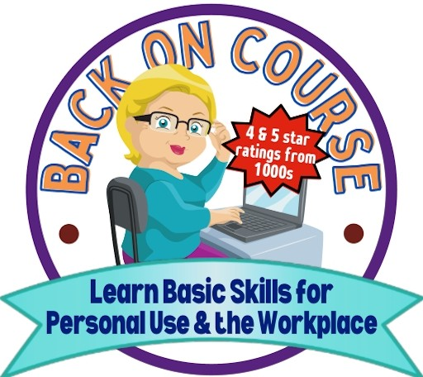*Mike Wilson's Computer/Digital Literacy Skills Training*

*SENIORS' SERIES*

# Mike Wilson's "Computer/Digital Literacy Skills" Checklist

*(Please check off the features we discuss in class)*

**Understanding Computer Hardware Optional Online *After Class* Self-Tests**

***and* Certificates of Completion**

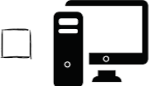**Desktop Computers** - This computer has four hardware components: the monitor, tower, keyboard, and mouse.

□O

=

□*_:::.·*=*::::::.*

**All-In-One Computers** - This computer has the hardware components built into the monitor and only has a monitor, keyboard, and mouse.

**Laptop Computers** - This computer is one unit. The lid (monitor) of the computer can be folded down on the keyboard. This type of computer is used to carry.

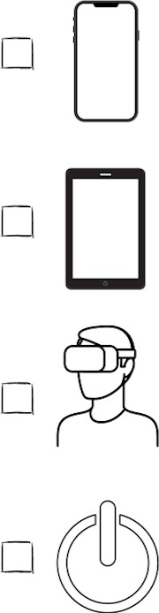**Cell Phones** - Cell phones are "smart phones" because they can be used to pay bills, check emails, give directions, take pictures, create notes, plan calendars, and so much more!

**Tablets** - Tablets are flat hand-held devices with a built-in keyboard on the screen. Tablets have similar features to cell phones.

**Virtual Reality Headsets** - A virtual world takes place when you put on these goggles. Whatever you are viewing comes alive in 3-D. It's like the real thing!

**Power Buttons on Devices** - The power button is used to turn on and shut down your computer. It's a good idea to close out of all your programs and files before shutting down.

### Understanding Your Desktop, Icons, and Taskbar

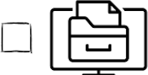Your Windows computer consists of a desktop, icons, and taskbar. The desktop is the large background you see after turning on your computer and bypassing any password screens. This desktop is treated like the desk you have in your home or office. On top of your desk you may have papers, folders, files, and other things. Likewise, the computer desktop displays icons that represent these things. Also, the taskbar is the long bar at the bottom of the screen that displays features like the start button, search feature, the time/date and other helpful features. **Explore and identify the desktop, icons, and taskbar features.**

### Opening Your Free Word Processor

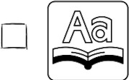Microsoft WordPad is a free word processor located on your computer. You will need to open the app in order to complete the steps in the next two entries below, under *"Using Keyboard Shortcuts".* Instructor will demonstrate in class how to open WordPad using the Search box.

### Using Keyboard Shortcuts

□ [llllllr **Basic Keyboard Keys** - There's a few keys you should know about. These are the backspace, delete, caps lock, and shift keys. **Open WordPad, type characters and practice these keys.**

0 + **Shortcuts** - Keyboard shortcuts are used to make the user's tasks easier. Some helpful shortcuts are CTRL+P, for print; CTRL+A, for selecting all text; and CTRL+Z, for recovering

from errors or undoing something you previously did. **Open WordPad, type a sentence, and try simply holding down the CTRL key as you tap and release one of the keys above.**

*SENIORS' SERIES* - ***"Computer/Digital Literacy Skills" Checklist (Continued)***

### Mouse and Touchpad Pointer Shapes

0 There are four basic mouse pointer shapes: 1) The flashing vertical bar; 2) The arrow pointer; 3) the i-beam; and 4) the link select (hand) tool, used mainly for the Internet to click on text and

graphic links. **Visit a website to "hover" and click with the "select tool" to explore the pages.**

### Using a Camera and Microphone

l, There are apps, such as Zoom, that require a good camera and microphone if the user will make

* 111 a good presentation. **If you want to be seen and heard, you will need to purchase a webcam**

(with mic) **for desktop computers that do not have a built-in microphone and camera.**

### Basic Computer Storage

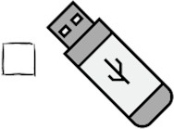Using flash drives, external drives, or a cloud service are ways to make copies of your work. You can back up your precious documents and pictures by inserting a flash drive into your computer, then going to, let's say, a picture you want to copy to the flash drive. **Right-click on the picture and then left click on "send to". Locate the flash drive from the list and left click on it.** (Note: Your flash drive might have a name such as: removable, removable disc, USB..., USB Drive, or the manufacturer's name, like SanDisk.) A copy of your picture is now on the flash drive. **Follow the same steps to copy a document to a flash drive.**

### Recognizing and Navigating Features Used in Apps and Online Areas

The desktop computer, all-in-one computer, laptop, tablet, and cell phones all use apps (software) to accomplish some amazing things. There are thousands of apps that cover many needs.

**The following seven symbols on this page can be viewed on apps and online:**

0 **Menu** - Clicking on this symbol displays a menu with a list of options. **Open your calculator or your News app and explore different features** using the Menu icon.

* ••••

•



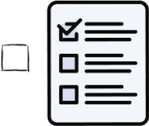

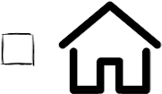

b

**0 0**

**More** - Clicking either the horizontal or vertical symbols display a list of features that the user can click on to change the current feature. Google Chrome and Microsoft Edge have this feature in the upper right of their browsers. The News app has this feature also. **Click their icons to view the lists.**

**Search** - The Search feature can be used to search the content you are currently in. For example, apps can be found at the Microsoft Store, using the search feature. **Click the Start Button, then click on the Microsoft Store and type in an app category in the search feature.**

**Check Boxes/Circles and Menu/Drop Down Lists** - These two features display lists of options the user can choose from. After each hour of Mike Wilson's Computer/Digital Literacy Training, you will have the option of taking a quiz based on what you have learned. The instructions for taking the quiz are on page 1. **There will be four quizzes you may take where you will use check boxes/circles and menu drop down lists.** See how many you get right! You can take each quiz up to two times.

**Home-** The Home icon/feature is used to return the user to the main area of an app or browser. Microsoft apps (Word, Excel, and PowerPoint), and Internet browsers have the home button located in the upper left of the screen. **Explore the apps and a browser and then return to Home.**

**Cart** - Online items can be placed in the cart before buying. them. The user can then go back and review the items before making purchases. Many shopping websites, such as Amazon have the cart feature. **Go to** [**www.amazon.com,**](http://www.amazon.com/) **select an item and put it in the cart.**

## Mike Wilson's "Online and Browser Essentials" Checklist

*(Please check off the features we discuss in class)*

**Optional Online *After Class* Self-Tests and Certificates of Completion**

**Online Essentials Checklist** The symbols on this page are not necessarily symbols

**a**

**found on devices, except for the Wi-Fi symbol below.**

* **Going Online** - A device that is "online" is connect to a network of computers. The largest

network of computers is the Internet or the World Wide Web (www). We pay Internet providers monthly fees to have online service. **Name three Internet providers.**

9

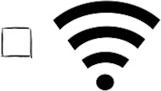**Understanding Your Home Wi-Fi and Router** - Your router, (a small box with blinking/solid lights), helps you get connected online. **Locate your home router.** (You might have a separate modem next to it.) **Carefully look on the side or underside of the router and see if you can locate a label with your router password/pin.** You should also see characters to the right of the letters: "SSID". These characters are the router/network name. You'll need the password and router name to reconnected if you get disconnected by a storm or some other source.

**Apps Used to Go Online** - Many apps need to be "online" in order to function properly. That means, for example, if you're not online and try to use your Maps app, you cannot explore locations. **Click your Start button and locate and open your "Maps" app and type in the Search Box a location at two cross streets to go to that location.**

0 **L-0**

**Browsers** - A browser is a program used to visit and look at websites online. You can also open a browser to check, send, and receive emails, as well as search for information. **Know the name of your browser and two other browser names.**

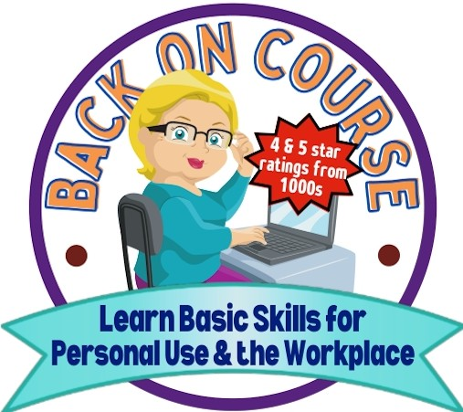

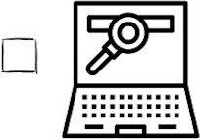**Browser Address Bar** - All browsers have similar features. They all have an address bar. The address bar is used to type in a known website or type in information you are enquiring about. **Click in the address bar and type in** [**www.bettycrocker.com,**](http://www.bettycrocker.com/) **then press the ENTER key on your keyboard to go to the website.**

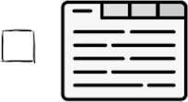**Using Browser Tabs** - Browser Tabs are used as a great and simple way to multi-task. When you have opened a browser, the tab(s) are located at the extreme top of your screen, labeled with the website name you are viewing or some text. Notice the plus (+) sign to the right of the last tab on the right. **Click the plus(+) sign to create an additional tab. You can now visit a website and click on any tab to the left of your current tab to access that website.**

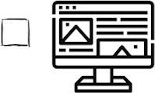**Saving Favorite Websites** - Browsers have a feature to save any website you visit. You can return to those sites anytime. Once you are at a website you would like to save, **locate and click the star symbol in the top right of the address bar, then click "done."** To return to a website you have saved, **click the three vertical dots** (upper right in the Google Chrome browser), **then choose "Bookmarks" from the list and click on your website name.** If you saved a website in Microsoft Edge, **click the three horizontal dots** (upper right), **then choose "Favorites"** from the list, and **click on your website name.**

**Find On Page** - You may visit a website or "Google" information and need to look through tons of words to find what you're looking for. You can easily find certain words/phrases by **clicking the "More" symbol** (see definition on previous page), and **click the words "find" or "find on page." Then type in your word or phrase and you'll see the word(s) highlighted.**

□

## Mike Wilson's "Getting The Most

**Out of Email" Checklist**

*(Please check off the features we discuss in class)*

### Email Features

**Optional Online *After* ClassSelf-Tests and Certificates *of* Completion**



**LearnBasic Skills for**

**PersonalUse& the Workplace**

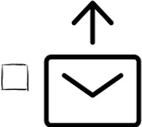**Sending An Email** - "Email" means electronic mail. Computer users can send and receive electronic mail (messages) to and from other computers. Here are the steps to send an email:

1) **open your email account, 2) type an email address in the "To:" section, 3) type a heading in the "Subject" section, 4) type a message in the message area, 5) Click the SEND button.**

**Receiving and Replying to an Email** - Here's how to respond to an email that has been sent to you. 1) **Open the email sent to you, 2) click on the REPLY or the left-facing arrow around the message, 3) type your message, 4) Click SEND.**

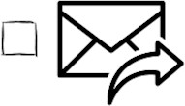**Forwarding an Email-** You can forward an email you got from someone.1) **Open the email sent to you, 2) click on FORWARD or the right-facing arrow around the message, 3) Click SEND.**

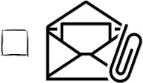**Attaching a Picture or Document** - Pictures you have on your device or on the cloud can be attached to your email message and sent to others. 1) **Follow steps 1- 4 above, under "Sending An Email", 2) Locate and click the PAPERCLIP icon,** (NOTE: Your email button may have a paperclip icon, or the word "attach," to click on.) This will display the dialog box to locate your picture. 3) **Locate and click on your picture.** Note: After clicking on your picture, there should be an "open" or "attach" button near your picture. 4) **Click on the button to attach the picture to your email, 5) Click the SEND button to send your message along with your attached picture.**

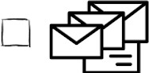**Sending Group Emails** - Follow the steps to send an email to a group of people: 1) **Compose an email and go into the "To:" section, 2) type in each email address followed by pressing the Tab key to separate the emails. 3) Click SEND,** and all the recipients will get your one email.

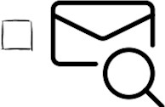**Searching for Emails** - You can find misplaced emails by using the email search box. The box is at the top center of your email account. **Simply type in some content in the search box and search for that information.** You can search by an email address or a unique word(s) in an email.

**lnbox** - The inbox is where a directory of all incoming mail is displayed. **Check your lnbox for any incoming mail that came to you 10 days ago.**

**Drafts** - Emails that you start on and don't send will automatically be sent to the drafts area. You can always return to the drafts area to resume composing draft email. **Create a pretend email and then click on DRAFTS from the list on the left.** Notice that the email has been automatically saved there.

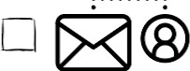**Contacts** - You create contacts similar to an address book. Names, emails, phone numbers, and other information can be entered in a contact. Once you have created a contact, you can easily use those names to email the people in your contacts. To create a contact, you need to **click the contact image and type in a person's contact information.** Once you have created a contact, the name will be there until you edit it or delete it.

*Mike Wilson's Computer/Digital Literacy Skills Training*

*SENIORS' SERIES*

## Mike Wilson's

**"Enjoy Learning Windows 10 and 11" Checklist**

*(Please check off the features we discuss in class)*

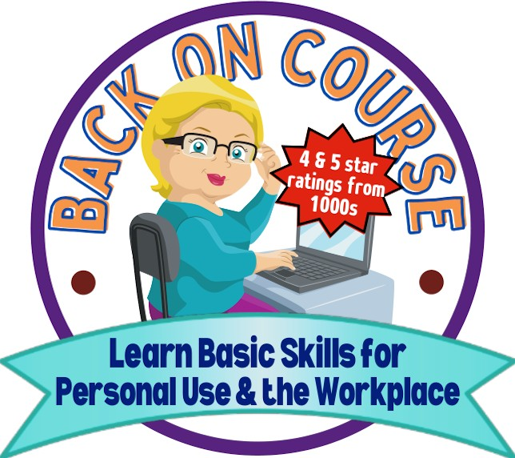**Optional Online *Aher* ClassSelf-*Tests* and*Certificates* of Completion**

### Windows Features

**Windows 10 and 11 Operating Systems** - We communicate with our computers through the

**l!!l** operating system. When your computer is turned on, you view your desktop, icons on the

* + desktop, the taskbar at the bottom, and other features. We become familiar with how these

features work. These are a part of the Windows 10 and 11 operating system. Whether you have a Dell, Hewlett-Packard (HP), Samsung, Lenovo, or one of the other PC computer manufacturers -- Windows 10 or 11 is the operating system on those computers. Apps are not the operating system. Apps are installed and are used to run with the operating system. The operating system manages apps and make them run. **Identify your operating systems' desktop, icons on the desktop, the taskbar, and the start button.**



* + ••••

■■

**Desktop Background** - Your desktop is the background that covers the monitor after you have started your computer and by-passed the initial startup screen. The desktop background can be changed to different colors. You may also use pictures located on your computer as desktop backgrounds. **Right-click on a blank area of the desktop and left-click PERSONALIZE from the list. Left-click on the word BACKGROUND and choose PICTURE.** Left-click on any color to change your desktop background.

**Start Button** - The Start Button is the icon located on the taskbar, in the extreme lower left corner of the screen (Windows 10) or in the lower-left center of the screen (Windows 11). When you click the Start Button, it will display the Start Menu. **Click the START BUTTON on Windows 10 or 11** to view the start menu.

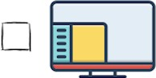**Start Menu - Locate and click the Start Button** for either Windows 10 or 11 (see entry above). This will display the Start Menu. You'll see areas divided into sections. Notice the alphabetical list of apps on the left side (Windows 10). To view the alphabetical apps in Windows 11, **click the words ALL APPS** (in the upper right corner of the Start Menu.)

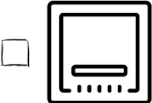**Task Bar** - The task bar is the long bar covering the bottom of your screen. Notice the features on the taskbar, which include the Start Button, and may include the Search, File Explorer, The Microsoft Store, Microsoft Edge. and the icons/buttons located on the far right of the taskbar. **Click on the time/date on the right side of the taskbar** to explore the calendar.

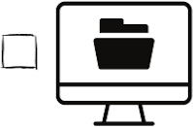**Creating and Naming a Folder on the Desktop** - Folders are where files, and/or other folders can be stored for convenience and order. **Right-click with mouse on a blank area of the desktop.** A list will be displayed. **Place mouse pointer over the word NEW** (a submenu will be displayed.) **Left-click only once on the word FOLDER from the submenu.** This will create a folder on the desktop, titled "New Folder" **Do not click the mouse at this point, but begin typing a name for the folder** (this will replace the words "New Folder") **Press ENTER on the keyboard.**